**CAREER GUIDENCE**

A MINI PROJECT REPORT

**BACHELOR OF TECHNOLOGY**

in

**Computer Science Engineering**

**by**

**P.RAJIV(23L31A05I4) P.MANOJ KUMAR (23L31A05I5) P.SHREYAN NAIDU (23L31A05J1)  
P.PASYANTH(23L31A05J8) R.SOHAN (23L31A05J9)**

Under Esteemed guidance of

**Dr.CH VV Ramana**

Associate professor

Department of computer science Engineering



**VIGNAN’S INSTITUTE OF INFORMATION TECHNOLOGY**

**VISAKHAPATNAM(Autonomous)**

**(Approved by AICTE, New Delhi, Accredited by NBA**

**Affiliated to Jawaharlal Nehru Technological University, GURAJADA VIJAYANAGARAM)**

**Besides VSEZ, Duvvada, Vadlapudi Post, Gajuwaka**

**Visakhapatnam -530049, A.P., India.**

**2024-2025**

**VIGNAN’S INSTITUTE OF INFORMATION TECHNOLOGY**



**CERTIFICATE**

This is to certify that the project report entitled **“CAREER GUIDANCE”**

Is a Bonafide record of the work done by:   
**P.RAJIV(23L31A05I4)  
P.MANOJ KUMAR (23L31A05I5)  
P.SHREYAN NAIDU (23L31A05J1)  
P.PASYANTH(23L31A05J8)  
R.SOHAN (23L31A05J9)**   
In the department of COMPUTER SCIENCE ENGINEERING, Vignan’s Institute of Information Technology, Visakhapatnam.

**Head of the Department Project Guide**

Dr. B. Dinesh Reddy Dr. CH VV Ramana

Professor and Head of Department Associate Professor

Department of COMPUTER SCIENCE ENGINEERING

Vignan’s Institute of Information Technology

**EXTERNAL EXAMINER**

**ACKNOWLEDGEMENT**

It is privilege for me to present on "CAREER GUIDENCE" submitted to computer science and engineering, Vignan' s institute of information technology (autonomous) Duvvada, in partial fulfilment of requirement for award of "B-TECH IN COMPUTER SCIENCE AND ENGINEERING

I take this opportunity to express my deep and sincere indebtedness to our guide

Sri Dr. Ch. V. Ramana, PhD Associate Professor in COMPUTER SCIENCE AND ENGINEERING for his guidance, support and encouragement in completion of this project work.

I intent to express my thanks with obedience to our Head of Computer Science and Engineering Dr. B. Dinesh Reddy for his valuable suggestions and instant motivation in bringing out this project work.

I feel happy to convey my sincere thanks to our principal for his kind co-operation in providing all provisions for the successful completion of the project.

I am thankful to all other staff members of Computer science engineering department in the completion of this project.

I am also thankful to my friends and my batch co-students for their interest, assistance and helpful suggestion. Lastly, I am grateful to one and all that help me in the completion of the project work.

**ABSTRACT**

In today's competitive world, choosing the right career path is a critical decision. This project introduces a comprehensive Career Guidance Web Page designed to assist users in exploring various job roles and providing them with the necessary information and preparation strategies to achieve their career goals. This full-stack web application offers a unique approach by not only listing potential career paths but also offering detailed guidance on how to pursue them.

**Key Features:**

* **Job Role Exploration:** Users can browse through a wide range of job roles.
* **Detailed Information:** For each job role, the platform provides in-depth information, including job descriptions, required skills, and potential career growth.
* **Preparation Strategies:** The web page offers tailored preparation strategies, including recommended educational paths, relevant courses, and essential certifications.
* **Full-Stack Development:** The application is built using a robust full-stack architecture, ensuring a seamless and interactive user experience..

**Benefits:**

* **Informed Decision-Making:** Empowers users to make informed decisions about their career paths.
* **Comprehensive Guidance:** Provides end-to-end guidance, from exploring job roles to preparing for them.
* **Accessibility:** Offers a user-friendly platform accessible to anyone seeking career guidance.
* **Time-Saving:** Consolidates all necessary information and resources in one place, saving users valuable time.

The Career Guidance Web Page serves as a valuable resource for students, graduates, and anyone looking to make a career change. It equips them with the knowledge and tools needed to navigate the complexities of the job market and achieve their professional aspirations.

**CONTENTS**

**S.NO CHAPTER NAME**

1. Introduction

1.1 - Purpose of the project

1.2- Importance of career guidance

1.3- Objectives of the Career guidance web page

2. Problem Statement

2.1 – Giving the proper Career Guidance for the freshers

2.2- Giving the Job assistance for the job searchers

3. Proposed Solution

3.1- Overview of the Career Guidance Platform

3.2 - How it works and Guidence Mechanism

4. Platform Design & Architecture

4.1 – Platform workflow

4.2- Key modules:

4.2.1- Profile Analyzer Module

4.2.2-Career Matcher

4.2.3- Resource Locator

4.2.4- User Interface

4.2.5- Flow diagram and architecture sketch

5. Technologies Used

5.1 - **HTML, CSS, JavaScript**

5.2- **Express.js Framework and Node.js**

5.3- **MongoDB Database**

5.4- **Node.js Libraries**

6. Implementation Details

6.1 - Description of how each module works

6.2- Code

6.3- Screenshots of the road maps and web pages in use

7. Testing & Results

7.1 - **Enhanced AI Algorithms**

7.2- **Data Integration and Partnerships**

7.3- **Gamified User Engagement**

**7.4- Ethical AI Practices**

**7.5- Continuous Learning**

**7.6- Accessibility**

8. Limitations & Future Work

8.1 - Current limitations (e.g., gathering the past data correctly)

8.2- Ideas for improvement (AI-based gathering, updation of data, etc..)

9. Conclusion

09.1- Summary of what was achieved

09.2- Final thoughts on usefulness and impact

**CHAPTER 1**

**INTRODUCTION**

* 1. **Purpose of the Project**

The Career Guidance Application serves as a comprehensive digital companion designed to transform how individuals navigate their professional journeys across all career stages. At its core, the application addresses the fundamental disconnect between personal aptitudes, career aspirations, and market realities that often leads to professional dissatisfaction and misaligned career choices.

For students and recent graduates, the application provides structured pathways to self-discovery through sophisticated assessment tools that identify strengths, interests, values, and working styles. These insights are then algorithmically matched with career options that offer the highest probability of both professional success and personal fulfillment. This data-driven approach replaces the often arbitrary or peer-influenced decision-making that characterizes early career choices.

Working professionals facing mid-career transitions benefit from the application's ability to analyze transferable skills and identify adjacent career paths that leverage existing expertise while minimizing retraining requirements. The platform's real-time labor market intelligence highlights emerging opportunities and declining sectors, enabling proactive career planning rather than reactive job searching.

Ultimately, the Career Guidance Application aims to reduce career decision anxiety by replacing uncertainty with data-informed confidence. By providing continuous support through various career transitions, it transforms career development from a series of isolated decisions into an integrated, strategic journey. The application's purpose is not simply to match people with jobs, but to create alignment between individual potential, professional aspirations, and market opportunities—fostering more meaningful and sustainable career trajectories.

* 1. **Importance of career guidance:**

The fragmented nature of career information creates significant inefficiencies in career decision-making. Most individuals lack access to comprehensive, personalized guidance, resulting in career choices based on limited perspectives or outdated advice. Career guidance applications centralize vast amounts of occupational data, labor market trends, and skill requirements into accessible formats, enabling informed decisions rather than choices made in information vacuums.

The financial implications of misaligned career choices are substantial. Educational investments without clear career alignment often led to underemployment and skill underutilization. By helping users identify suitable career paths before committing to specific educational tracks, these applications help prevent costly academic detours and credential accumulation without corresponding employment opportunities.

As career trajectories become increasingly non-linear and self-directed, career guidance applications serve as critical navigation systems, helping individuals make intentional transitions rather than reactive job changes, ultimately supporting more sustainable and fulfilling professional journeys.

**1.3 Objectives of the Career guidance web page:**

A career guidance webpage aims to empower individuals with the knowledge and resources necessary to make informed decisions about their professional paths. Its primary objective is to provide comprehensive information about various career options, including industry trends, required skills, educational pathways, and potential earning prospects. By offering a centralized hub of reliable data, the webpage helps users explore diverse fields they might not have considered otherwise.

**A few key objectives of a career guidance webpage:**

* **Inform:** Provide comprehensive and reliable information about diverse career paths, industries, and required skills.
* **Explore:** Facilitate self-assessment tools and resources to help users understand their strengths, interests, and values in relation to career options.
* **Educate:** Offer guidance on educational pathways, training programs, and skill development necessary for different careers.
* **Equip:** Provide practical resources and advice on resume writing, interviewing skills, and job searching strategies to enhance employability.
* **Connect:** Offer access to support networks, career counsellors, and mentorship opportunities for personalized guidance.

**CHAPTER 2**

**Problem Statement**

In today's rapidly evolving job market, individuals face significant challenges when making career decisions. Many struggles with limited self-awareness about their skills and interests, lack access to comprehensive and personalized career information, and find it difficult to navigate the overwhelming amount of fragmented career resources available online.

Students, recent graduates, and professionals seeking career changes often make decisions based on incomplete information, peer pressure, or outdated perceptions rather than data-driven insights aligned with their personal attributes and market demands. This leads to job dissatisfaction, career stagnation, frequent job changes, and wasted educational investments.

**2.1 Giving the proper Career Guidance for the freshers:**

Embarking on your professional journey after graduation can be both exhilarating and overwhelming. Our career guidance application serves as your personalized navigator through these uncharted waters, providing data-driven insights tailored to your unique profile.

Begin your journey by completing our comprehensive assessment module, which analyses your strengths, interests, values, and learning style. This self-discovery process forms the foundation of effective career planning, revealing paths that align not just with market demand but with your authentic self. Many freshers rush into trendy fields without this crucial self-awareness, often leading to misalignment and career dissatisfaction later.

Our skills gap analyser compares your current capabilities against requirements for your target roles, creating personalized learning pathways to bridge these gaps. Remember that while your degree opened doors, your demonstrable skills will ultimately drive career advancement. Utilize our microlearning modules and project simulation features to build practical expertise that complements your academic knowledge. With consistent engagement and thoughtful use of our application's resources, you'll navigate your early career with greater confidence and strategic direction.

**2.2 :** **Giving the Job assistance for the job searchers :**

Navigating your career journey through our guidance application empowers you with personalized tools for more effective job searching. Begin by fully completing your profile assessment within the app, as this allows our algorithm to match you with opportunities that align with your unique skills, interests, and career goals, rather than overwhelming you with irrelevant listings.

Take advantage of the industry insights dashboard to understand current market trends, in-demand skills, and salary benchmarks specific to your target roles. This data-driven approach helps you position yourself strategically and set realistic expectations during negotiations. The interactive skills gap analyzer identifies areas for professional development and connects you directly to relevant learning resources and certification programs.

Remember that career development is an ongoing journey. Regularly update your profile as you gain new skills and experiences, allowing our system to continuously refine its recommendations. Set job search goals within the application and use the progress tracking features to maintain momentum. With consistent engagement and the strategic use of our platform's personalized guidance tools, you'll navigate your career path with greater confidence and clarity.

**CHAPTER 3**

**Proposed Solution: The Career Guidance Platform**

The Career Compass platform offers an intelligent, real-time solution to guide individuals toward suitable career paths. In addition to using predefined career categories and information, the platform is powered by a machine learning model trained on thousands of career trajectories, skill requirements, and local industry data specific to the Hyderabad region. This model helps analyze an individual's profile more accurately by learning patterns associated with successful career paths within the local job market.

The platform assesses user profiles as they are built and applies the trained model to suggest potential career matches and relevant educational pathways. If a career or educational path is flagged as potentially misaligned with the user's skills, interests, or the local job market, the user is provided with alternative suggestions and resources. This solution leverages both traditional career guidance principles and the predictive power of machine learning to provide a more dynamic and adaptive approach to career planning.

The platform is designed to be accessible, easy to use, and customizable, offering seamless guidance without overwhelming the user. It can be tailored to suit different user needs by adjusting the weighting of factors like interests, skills, and job market demand, and by incorporating information about local educational institutions and industries.

**3.1 Overview of the Career Guidance Platform:**

The Career Compass is a platform designed to enhance career exploration and planning by automatically identifying and suggesting relevant career paths and educational opportunities in real time. It functions as an accessible tool that users can engage with to receive personalized guidance tailored to the job market in Hyderabad and surrounding areas.

Once a user creates a profile, the platform continuously analyzes their skills, interests, academic background, and preferences. Using a combination of established career frameworks and a machine learning model trained on extensive data related to various careers and the specific demands of industries in Telangana, the platform evaluates potential career matches in real time. If a career path appears to be a strong fit, the platform provides detailed information, including required skills, potential employers in the region, and relevant educational institutions.

The platform is easy to use and highly customizable. Users can explore different career fields, understand the skills needed for specific roles, and identify local educational resources. It provides instant insights without requiring extensive research, making it ideal for students, recent graduates, and individuals looking to make career transitions in the Hyderabad job market

**3.2 How It Works and Guidance Mechanism:**

The Career Compass platform operates seamlessly to provide real-time guidance on career options relevant to the user and the local job market. Here's how it works:

* **User Profile Creation:** As a user creates a profile, they input information about their educational background, skills, interests, and any prior work experience. They may also indicate preferences regarding work environment, salary expectations, and industry focus.
* **Profile Analysis:** The platform analyses the user's profile in real-time. This involves evaluating various factors like stated skills, indicated interests, and academic qualifications, cross-referencing them with the demands of different career paths.
* **Career Matching:** The platform uses a combination of predefined career categories and a machine learning model trained on thousands of career trajectories and local job market data. The machine learning model has been trained to recognize patterns associated with successful careers in Hyderabad based on factors such as required skills, industry growth, and typical educational backgrounds.
* **Relevance Scoring:** After analysing the user's profile, the platform assigns a relevance score to potential career matches. If the score indicates a strong alignment between the user's profile and a particular career, it is highlighted as a suitable option.
* **Guidance and Resource Provision:** When a potential career path is identified, the platform provides detailed information, including:
  + Required skills and qualifications.
  + Potential employers in the Hyderabad region.
  + Relevant educational institutions and courses in Telangana.
  + Industry outlook and growth potential in the local context.
* **User Exploration:** Users could explore different career fields, understand the skills and education needed for various roles, and identify local resources. The platform allows users to delve deeper into specific career options that align with their interests and the local job market.

**CHAPTER 4**

**CHAPTER 4: Platform Design & Architecture**

The Career Compass platform is designed with a modular and scalable architecture to provide efficient and seamless career guidance relevant to the Hyderabad region. The system is divided into several core components that work together to analyses user profiles, suggest career paths, and provide relevant local resources.

* **Profile Analyzer Module:** The Profile Analyzer is the first step in the guidance process. It analyses the user's profile data as it is entered. This module evaluates various elements, including educational background, skills, interests, and work experience, to determine potential career alignments. It works in real-time, providing immediate feedback to the user.
* **Machine Learning Model:** The core of the platform's career guidance capabilities lies in the machine learning model. Trained on thousands of career trajectories, skill requirements, and job market data specific to Hyderabad and Telangana, the model is designed to recognize patterns that differentiate successful career paths. The model continually improves as it processes new user data and evolving job market trends, making the system smarter and more accurate over time. The model assigns relevance scores to potential career matches based on the user's profile.
* **Career Path Recommender:** Once the user's profile is analysed, the Career Path Recommender suggests relevant career options. This recommendation is based on predefined career frameworks and the output from the machine learning model. The recommender assesses the alignment between the user's profile and the requirements of various careers, considering factors like required skills, industry presence in Hyderabad, and typical educational backgrounds.
* **Resource Locator:** When a potential career path is identified, the Resource Locator module provides information about relevant local resources. This includes details about educational institutions in Telangana offering relevant courses, major companies in Hyderabad within that industry, and professional development opportunities available locally.
* **User Interface (UI):** The User Interface allows users to interact with the platform, build their profiles, explore career options, and access local resources. The interface is simple and intuitive, designed to be user-friendly for individuals at various stages of their career journey. Users can customize their preferences, explore different career fields, and view detailed information about suggested paths and local resources.
* **Notification System:** The Notification System alerts users about potential career matches, relevant local educational opportunities, and emerging job trends in the Hyderabad region that align with their profile. The system provides clear and concise messages to keep users informed and engaged

4.1 Platform Workflow:

The Career Compass platform operates through a streamlined workflow that allows it to analyze user profiles and suggest relevant career paths and local resources in real-time, providing users with seamless guidance as they explore their options. Below is a step-by-step breakdown of the workflow:

* **User Creates Profile:** The process begins when the user accesses the platform and creates a profile by entering information about their education, skills, interests, and experience.
* **Profile Analyzer Initiates:** As soon as the user's profile is submitted or updated, the Profile Analyzer module is triggered. This module begins analysing the entered data, evaluating elements like skills, academic background, and stated interests.
* **Profile Evaluation by Machine Learning Model:** The Profile Analyzer sends the user's profile data to the Machine Learning Model. This model, trained on extensive career and local job market data, identifies patterns and flags potential career paths that align with the user's profile and the demands of industries in Hyderabad.
* **Career Path Recommendation:** After receiving input from the machine learning model, potential career paths are recommended to the user based on a set of predefined career frameworks and the model's analysis. Each recommendation is assigned a relevance score indicating the strength of the match.
* **Resource Locator Activation:** When a career path is recommended, the Resource Locator module is activated. This module identifies and provides information about relevant local resources, such as educational institutions in Telangana offering related programs and companies in Hyderabad within that industry.
* **User Notification:** The platform displays a User Notification to alert the user about potential career matches and relevant local resources. The notification typically includes a summary of the suggested career path and links to more detailed information.
* **User Interface Interaction:** The user can access the User Interface to view recommended career paths, explore detailed information about each option, and access the provided local resources. The interface also allows users to refine their profile and explore other career fields.
* **Real-Time Updates & Feedback:** As users interact with the platform and provide feedback, this data can be used to further train and refine the machine learning model, allowing the platform to improve its accuracy and relevance over time for future users in the Hyderabad region.
* **Workflow Summary:**

|  |  |
| --- | --- |
|  | **Action** |
| 1 | User creates a profile. |
| 2 | Profile Analyzer scans the user's profile in real-time. |
| 3 | Machine Learning Model evaluates the profile data. |
| 4 | Relevant career paths are recommended. |
| 5 | Local resources for recommended paths are identified. |
| 6 | User receives a notification about potential matches. |
| 7 | User can interact with the UI to explore options. |
| 8 | Real-time updates and feedback improve the model |

|  |
| --- |
|  |

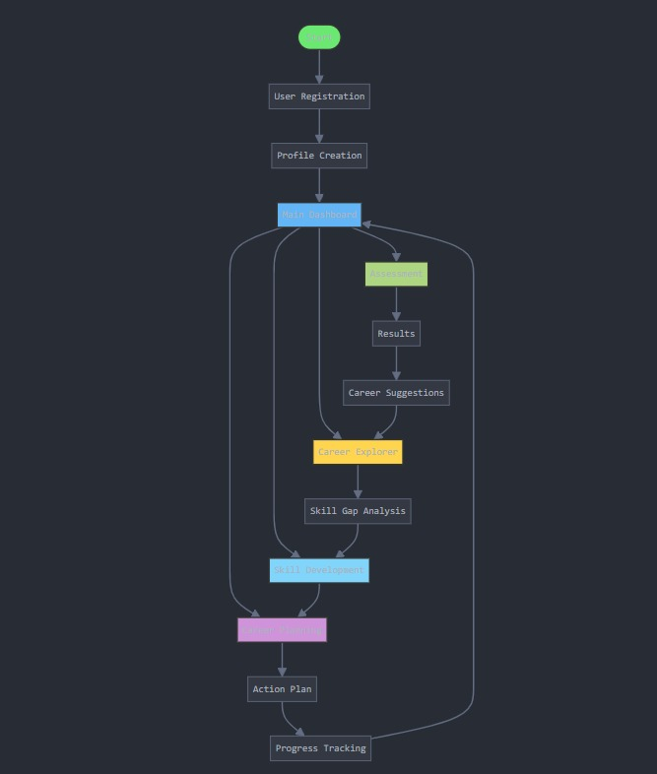

* 1. **- Key Modules**

4.2.1: **Profile Analyzer:** This module uses data analysis and potentially Natural Language Processing (NLP) to understand the user's skills, interests, and experience from their profile. It identifies keywords and patterns that align with different career fields.

4.2.2: **Career Matcher:** The Career Matcher categorizes various career paths based on required skills, education, industry trends in Hyderabad, and potential growth. It identifies domains that are prevalent or emerging in the local job market (e.g., IT, pharmaceuticals, manufacturing, services) and classifies them into relevant categories.

**4.2.3: Resource Locator:** This module identifies and provides links to relevant local educational institutions (universities, colleges, vocational training centers in Telangana), potential employers in Hyderabad, and professional development resources available in the region.

**4.2.4: User Interface:** A user-friendly dashboard where individuals can create and manage their profiles, view recommended career paths, access information about required skills and local resources, and provide feedback. It can include features for exploring different industries and understanding career progression within the Hyderabad context.

**4.2.5: Flow Diagram / Architecture Sketch:**

* 1. A visual representation of the platform's workflow.
  2. It includes the data flow between the profile analyzer, career matcher, resource locator, and UI.
  3. This diagram helps stakeholders understand the interaction between modules in providing career guidance

**CHAPTER 5**

**5. Technologies Used**

**5.1 - HTML, CSS, JavaScript:**

* **Used to design and develop the frontend interface for the career guidance web application, ensuring a responsive and user-friendly experience.**

**5.2 - Express.js Framework and Node.js:**

* **Utilized for backend development, enabling seamless interaction between the database and frontend while handling APIs, user authentication, and server-side logic efficiently.**

**5.3 - MongoDB Database:**

* **MongoDB powers the application's data storage and management, storing user profiles, career recommendations, and other relevant data in a flexible, scalable manner.**

**5.4 - Node.js Libraries:**

* **Leveraged Node.js libraries such as mongoose (for MongoDB integration), passport (for user authentication), and dotenv (for managing environment variables) to streamline backend operations and enhance functionality.**

### Key Tools and Libraries:

* **Backend Framework:** Express.js for routing and middleware handling.
* **Database:** MongoDB for data storage and management.
* **Node.js Libraries:** Mongoose, Passport, Bcrypt, Dotenv, and other libraries that streamlined development.
* **Development Tools:** Postman for API testing, Visual Studio Code for coding, and Git for version control.

**CHAPTER 6**

**6. Implementation Details**

**The system is built as a career guidance web application with a Node.js backend, MongoDB database, and a user-friendly interface. The key components of the implementation include:**

**6.1 - Frontend (Web Application)**

* **Developed using HTML, CSS, and JavaScript to create a responsive and interactive user interface.**
* **Features input forms, dashboards, and real-time interactions for career recommendations.**
* **Integrates Gemini 1.5 flash for an engaging chatbot appearance, ensuring user-friendly conversation flows.**

**6.2 - Backend Services**

* **Powered by Node.js with the Express.js framework, providing robust server-side functionality.**
* **Handles routing, API endpoints, and business logic for career guidance processes.**
* **Ensures smooth integration with the MongoDB database for dynamic data retrieval and storage.**

**6.3 - Database (MongoDB)**

* **Utilizes MongoDB for scalable and flexible data management, storing user profiles, career recommendations, and preferences.**
* **Implements efficient querying and data manipulation to provide relevant career insights.**

**6.4 - Chatbot Module**

* **Developed using Gemini 1.5 flash for chatbot appearance, offering a visually appealing and interactive user experience.**
* **The chatbot interacts with users to gather career-related inputs and provides recommendations based on their preferences.**

**6.5 - User Interface**

* **Features dashboards for users to view personalized career recommendations, track progress, and set preferences.**
* **Allows for seamless interaction with the chatbot and other features of the application.**

**Key Features**

* **Frontend Technologies: HTML, CSS, JavaScript for dynamic interfaces.**
* **Backend Technologies: Express.js and Node.js for smooth operations.**
* **Database: MongoDB for storing and managing user data.**
* **Interactive Chatbot: Gemini 1.5 flash for chatbot appearance and conversational guidance.**
* **Development Tools: Visual Studio Code, Postman for testing APIs, and Git for version control.**

**Code:**

**1. Project Initialization: Setting Up the Environment**

**The code begins by setting up an Express.js server. This is the backbone of the application, facilitating the communication between users and the system.**

**javascript**

**const express = require('express'); // Framework for server-side functionality**

**const mongoose = require('mongoose'); // Database connection**

**const session = require('express-session'); // User session handling**

**const MongoStore = require('connect-mongo'); // Store sessions in MongoDB**

**const path = require('path'); // Handle file paths**

**const bodyParser = require('body-parser'); // Parse incoming request bodies**

**const app = express();**

**const PORT = process.env.PORT || 4000; // Define server port**

**// Middleware Configuration**

**app.use(bodyParser.json());**

**app.use(express.urlencoded({ extended: true }));**

**app.set('view engine', 'ejs'); // View engine for rendering dynamic pages**

**app.use(express.static('public')); // Serve static files**

**Purpose:**

* **This sets up the technical foundation of the application, ensuring smooth and efficient interactions between the frontend, backend, and database.**

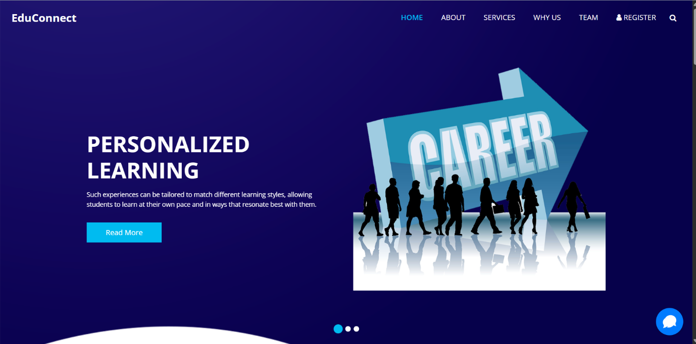

**2. Database Connection**

**The code now connects to MongoDB, a NoSQL database, which acts as a central storage for user profiles, career recommendations, quiz results, and other relevant data.**

**javascript**

**const MONGO_URI = "mongodb://127.0.0.1:27017/career_guidance";**

**mongoose.connect(MONGO_URI, { useNewUrlParser: true, useUnifiedTopology: true })**

**.then(() => console.log('Database connection successful'))**

**.catch(err => console.error('Database connection error:', err));**

**Purpose:**

* **Establishes a reliable database for storing and retrieving user data, ensuring scalability and performance.**

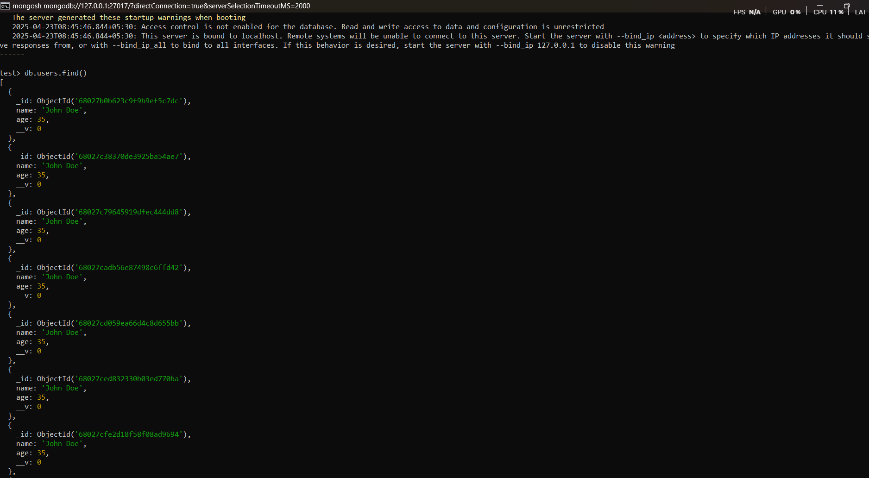

**3. Session Management**

**Sessions are crucial for maintaining a user's logged-in state across the application.**

**javascript**

**app.use(session({**

**secret: 'SuperSecureKey', // Encryption key for session**

**resave: false,**

**saveUninitialized: true,**

**store: MongoStore.create({ mongoUrl: MONGO_URI, collectionName: 'sessions' }) // Store session data in MongoDB**

**}));**

**Purpose:**

* **Enables persistent user experiences, such as remembering login states and storing temporary data (e.g., quiz responses).**

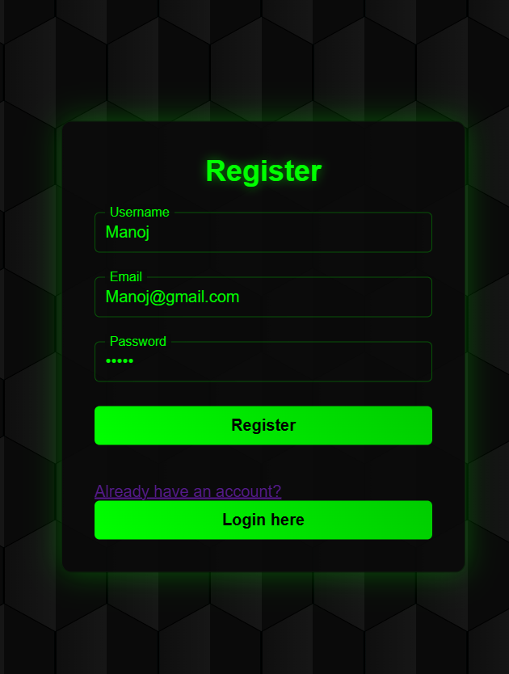

**4. Authentication Logic**

**The application includes middleware for checking user authentication before accessing sensitive routes.**

**javascript**

**const isAuthenticated = (req, res, next) => {**

**if (req.session.isAuth) {**

**return next();**

**}**

**res.redirect('/login'); // Redirect if not authenticated**

**};**

**Purpose:**

* **Secures sensitive pages like the dashboard and profile settings, preventing unauthorized access.**

**5. Defining User Routes**

**User interaction begins with authentication (login, registration) and continues to profile management.**

**javascript**

**app.get('/login', (req, res) => res.render('login')); // Login page**

**app.get('/register', (req, res) => res.render('register')); // Registration page**

**app.get('/dashboard', isAuthenticated, (req, res) => {**

**const user = {**

**username: req.session.user,**

**email: req.session.email || 'user@example.com',**

**profilePhoto: req.session.profilePhoto || '/images/default-profile.png'**

**};**

**res.render('dashboard', { user }); // Render dashboard for logged-in user**

**});**

**Purpose:**

* **Provides a seamless user experience for accessing the system, managing personal data, and tracking progress.**

**6. Career Exploration Feature**

**The application dynamically serves pages for different career paths. Users can explore comprehensive details about various professions.**

**javascript**

**const careers = [**

**{ id: 'counselor', name: 'Counselor' },**

**{ id: 'creative-writer', name: 'Creative Writer' },**

**{ id: 'data-scientist', name: 'Data Scientist' },**

**{ id: 'entrepreneur', name: 'Entrepreneur' },**

**{ id: 'graphic-designer', name: 'Graphic Designer' },**

**{ id: 'manager', name: 'Manager' },**

**{ id: 'mechanical-engineer', name: 'Mechanical Engineer' },**

**{ id: 'project-manager', name: 'Project Manager' },**

**{ id: 'research-scientist', name: 'Research Scientist' },**

**{ id: 'social-worker', name: 'Social Worker' },**

**{ id: 'software-engineer', name: 'Software Engineer' }**

**];**

**careers.forEach(career => {**

**app.get(`/career/${career.id}`, (req, res) => {**

**res.render('career', { career }); // Dynamically render career pages**

**});**

**});**

**Purpose:**

* **Empowers users to explore diverse career options and gain insights into roles aligned with their interests.**

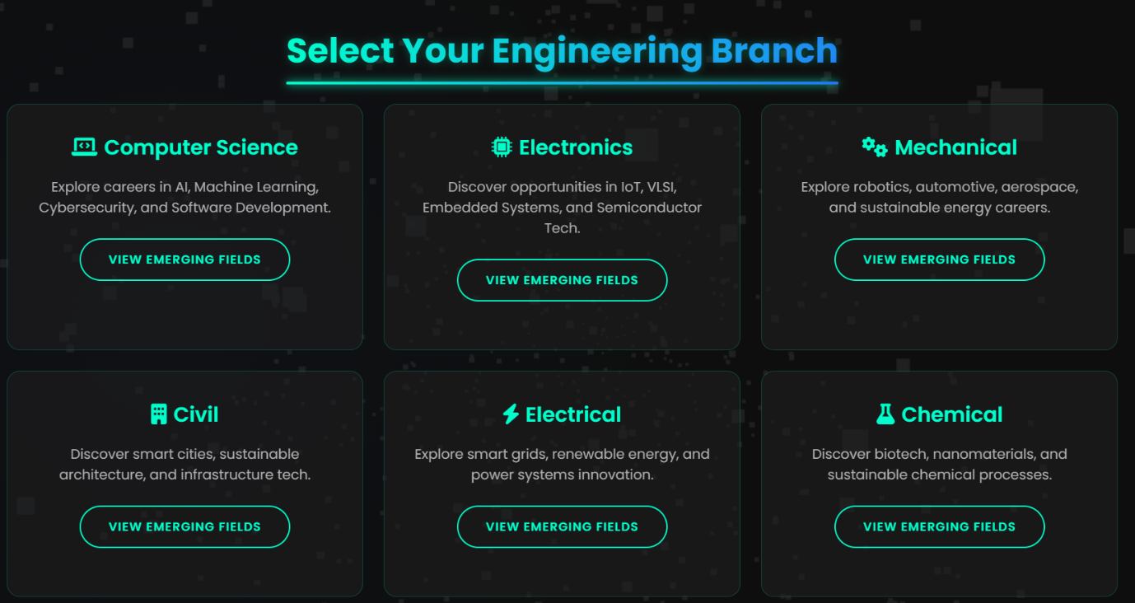

**7. Interactive Quiz Handling**

**Quizzes are integral for assessing user preferences and recommending suitable careers.**

**javascript**

**app.post('/career-quiz', isAuthenticated, (req, res) => {**

**const { answers } = req.body;**

**// Analyze quiz responses and suggest careers**

**const recommendations = analyzeQuiz(answers);**

**req.session.recommendations = recommendations; // Save recommendations in session**

**res.redirect('/dashboard'); // Redirect to dashboard**

**});**

**function analyzeQuiz(answers) {**

**// Sample logic for career analysis**

**return ['Software Engineer', 'Data Scientist']; // Example recommendations**

**}**

**Purpose:**

* **Captures user inputs, processes them using advanced logic, and offers personalized recommendations.**

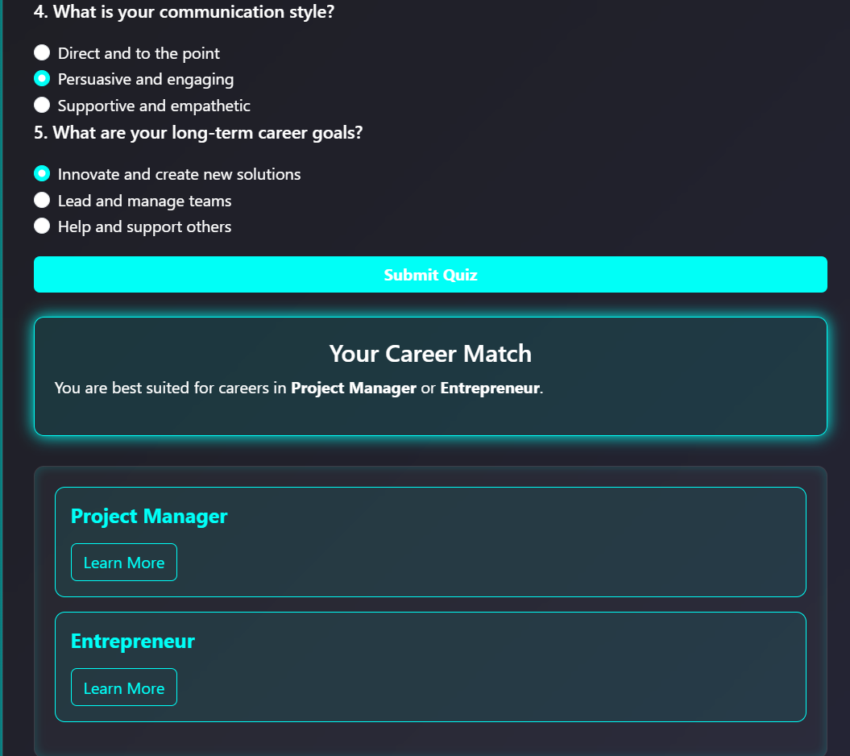

**8. User Dashboard with Career Progress Tracking**

**The dashboard is the central hub for users to monitor their career exploration and progress.**

**javascript**

**// Dashboard Route**

**app.get('/dashboard', isAuthenticated, (req, res) => {**

**const user = {**

**username: req.session.user,**

**email: req.session.email || 'user@example.com',**

**recommendations: req.session.recommendations || [],**

**quizProgress: req.session.quizProgress || 0**

**};**

**res.render('dashboard', { user });**

**});**

**Purpose:**

* **Tracks the user's career exploration journey by showing quiz progress and recommended careers.**
* **Acts as the go-to view for users to manage their interaction with the app.**

**Output View (HTML):**

**html**

**<!DOCTYPE html>**

**<html lang="en">**

**<head>**

**<title>User Dashboard</title>**

**</head>**

**<body>**

**<h1>Welcome, <%= user.username %>!</h1>**

**<p>Email: <%= user.email %></p>**

**<h2>Career Recommendations:</h2>**

**<ul>**

**<% user.recommendations.forEach(rec => { %>**

**<li><%= rec %></li>**

**<% }) %>**

**</ul>**

**<h2>Quiz Progress:</h2>**

**<p>You have completed <%= user.quizProgress %>% of the career quiz.</p>**

**<a href="/career-quiz">Continue Career Quiz</a>**

**</body>**

**</html>**

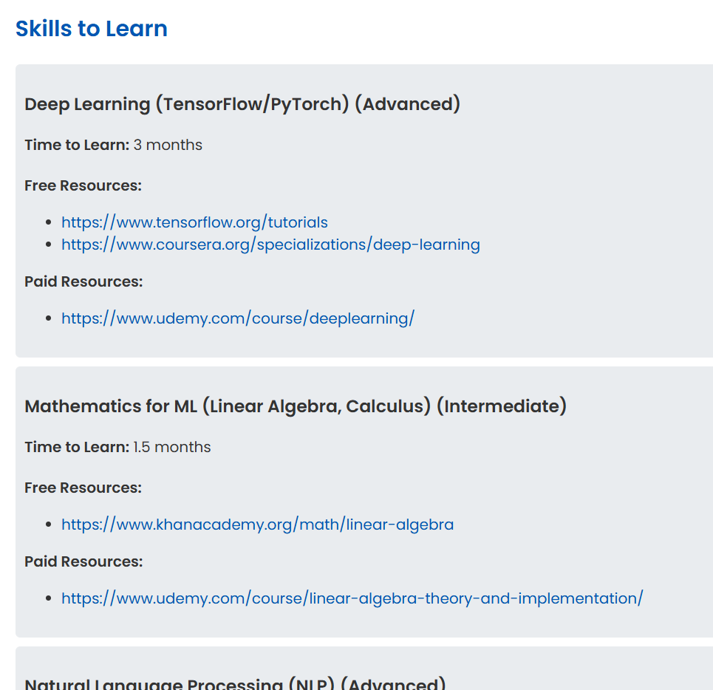

**9. Advanced Career Quiz Handling**

**This enhanced quiz system analyzes user preferences and provides real-time progress updates.**

**javascript**

**// Career Quiz Route**

**app.post('/career-quiz', isAuthenticated, (req, res) => {**

**const { answers } = req.body;**

**// Analyze quiz responses**

**const recommendations = analyzeQuiz(answers);**

**const progress = calculateProgress(answers);**

**// Save recommendations and progress in the session**

**req.session.recommendations = recommendations;**

**req.session.quizProgress = progress;**

**res.redirect('/dashboard');**

**});**

**function analyzeQuiz(answers) {**

**// Placeholder logic for analyzing quiz results**

**return ['Software Engineer', 'Data Scientist']; // Example recommendations**

**}**

**function calculateProgress(answers) {**

**// Calculate quiz progress based on completed answers**

**const totalQuestions = 10; // Example total questions**

**const completedAnswers = Object.keys(answers).length;**

**return Math.round((completedAnswers / totalQuestions) * 100);**

**}**

**Purpose:**

* **Dynamically tracks user progress and provides personalized career recommendations.**
* **Improves engagement by showing real-time progress updates.**

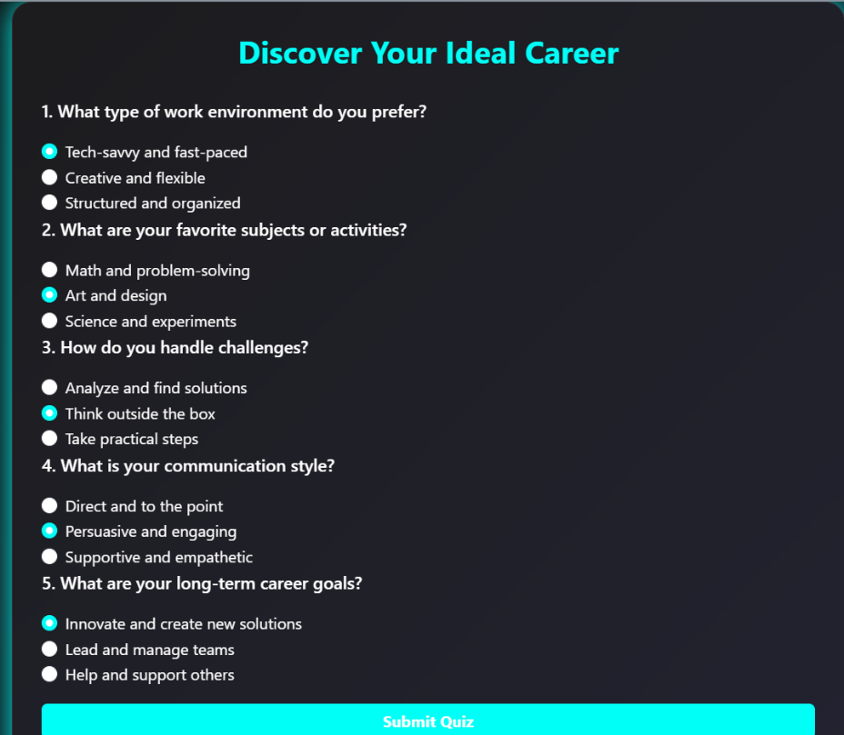

**11. Displaying B.Tech Branches**

**javascript**

**// Route for B.Tech Branches**

**app.get('/btech-branches', isAuthenticated, (req, res) => {**

**const branches = [**

**{ id: 'cse', name: 'Computer Science and Engineering' },**

**{ id: 'ece', name: 'Electronics and Communication Engineering' },**

**{ id: 'mech', name: 'Mechanical Engineering' },**

**{ id: 'civil', name: 'Civil Engineering' },**

**{ id: 'eee', name: 'Electrical and Electronics Engineering' },**

**];**

**res.render('btech-branches', { branches });**

**});**

**Output View (btech-branches.ejs):**

**html**

**<!DOCTYPE html>**

**<html lang="en">**

**<head>**

**<title>B.Tech Branches</title>**

**</head>**

**<body>**

**<h1>Select Your B.Tech Branch</h1>**

**<ul>**

**<% branches.forEach(branch => { %>**

**<li><a href="/emerging-jobs/<%= branch.id %>"><%= branch.name %></a></li>**

**<% }) %>**

**</ul>**

**</body>**

**</html>**

**Purpose: Displays all B.Tech branches and allows users to proceed to emerging jobs specific to the selected branch.**



**12. Emerging Jobs Based on Branch**

**javascript**

**// Route for Emerging Jobs**

**app.get('/emerging-jobs/:branchId', isAuthenticated, (req, res) => {**

**const jobs = getEmergingJobs(req.params.branchId);**

**res.render('emerging-jobs', { jobs });**

**});**

**function getEmergingJobs(branchId) {**

**const jobData = {**

**cse: ['AI/ML Engineer', 'Cybersecurity Specialist', 'Cloud Architect'],**

**ece: ['IoT Developer', 'Embedded Systems Engineer', 'VLSI Engineer'],**

**mech: ['Robotics Engineer', 'Thermal Design Engineer', 'Automobile Engineer'],**

**civil: ['Structural Engineer', 'Urban Planner', 'Geotechnical Engineer'],**

**eee: ['Power Systems Engineer', 'Smart Grid Specialist', 'Automation Engineer'],**

**};**

**return jobData[branchId] || [];**

**}**

**Output View (emerging-jobs.ejs):**

**html**

**<!DOCTYPE html>**

**<html lang="en">**

**<head>**

**<title>Emerging Jobs</title>**

**</head>**

**<body>**

**<h1>Emerging Jobs</h1>**

**<ul>**

**<% jobs.forEach(job => { %>**

**<li><%= job %></li>**

**<% }) %>**

**</ul>**

**<a href="/dashboard">Back to Dashboard</a>**

**</body>**

**</html>**

**Purpose: Lists cutting-edge jobs relevant to the selected branch.**

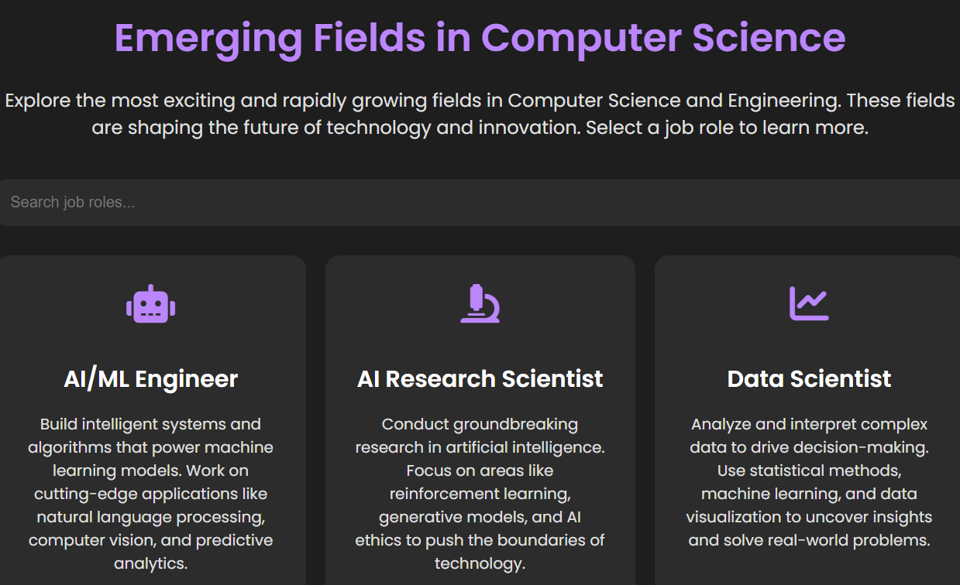

**13. Company Complexities**

**javascript**

**// Route for Company Complexities**

**app.get('/company-complexities', isAuthenticated, (req, res) => {**

**const companies = [**

**{ name: 'Google', complexity: 'High' },**

**{ name: 'Microsoft', complexity: 'Moderate' },**

**{ name: 'Amazon', complexity: 'High' },**

**{ name: 'OpenAI', complexity: 'Very High' },**

**{ name: 'NVIDIA', complexity: 'High' },**

**];**

**res.render('company-complexities', { companies });**

**});**

**Output View (company-complexities.ejs):**

**html**

**<!DOCTYPE html>**

**<html lang="en">**

**<head>**

**<title>Company Complexities</title>**

**</head>**

**<body>**

**<h1>Company Complexities</h1>**

**<table>**

**<tr>**

**<th>Company</th>**

**<th>Complexity Level</th>**

**</tr>**

**<% companies.forEach(company => { %>**

**<tr>**

**<td><%= company.name %></td>**

**<td><%= company.complexity %></td>**

**</tr>**

**<% }) %>**

**</table>**

**<a href="/dashboard">Back to Dashboard</a>**

**</body>**

**</html>**

**Purpose: Highlights the complexities of working with top companies for a better understanding of career challenges.**

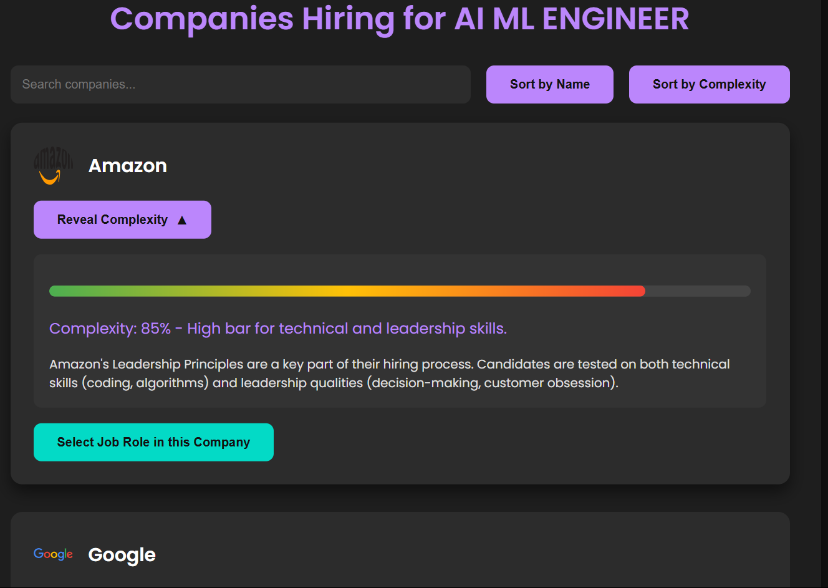

**14. Skill Gap Analysis**

**javascript**

**// Route for Skill Gap Analysis**

**app.get('/skill-gap-analysis', isAuthenticated, (req, res) => {**

**const skillData = [**

**{ skill: 'Machine Learning', demand: 90, supply: 50 },**

**{ skill: 'Cybersecurity', demand: 85, supply: 60 },**

**{ skill: 'IoT', demand: 80, supply: 40 },**

**];**

**res.render('skill-gap-analysis', { skillData });**

**});**

**Output View (skill-gap-analysis.ejs):**

**html**

**<!DOCTYPE html>**

**<html lang="en">**

**<head>**

**<title>Skill Gap Analysis</title>**

**</head>**

**<body>**

**<h1>Skill Gap Analysis</h1>**

**<table>**

**<tr>**

**<th>Skill</th>**

**<th>Demand (%)</th>**

**<th>Supply (%)</th>**

**</tr>**

**<% skillData.forEach(skill => { %>**

**<tr>**

**<td><%= skill.skill %></td>**

**<td><%= skill.demand %></td>**

**<td><%= skill.supply %></td>**

**</tr>**

**<% }) %>**

**</table>**

**<a href="/dashboard">Back to Dashboard</a>**

**</body>**

**</html>**

**Purpose: Identifies areas where there is a mismatch between industry demand and available talent.**

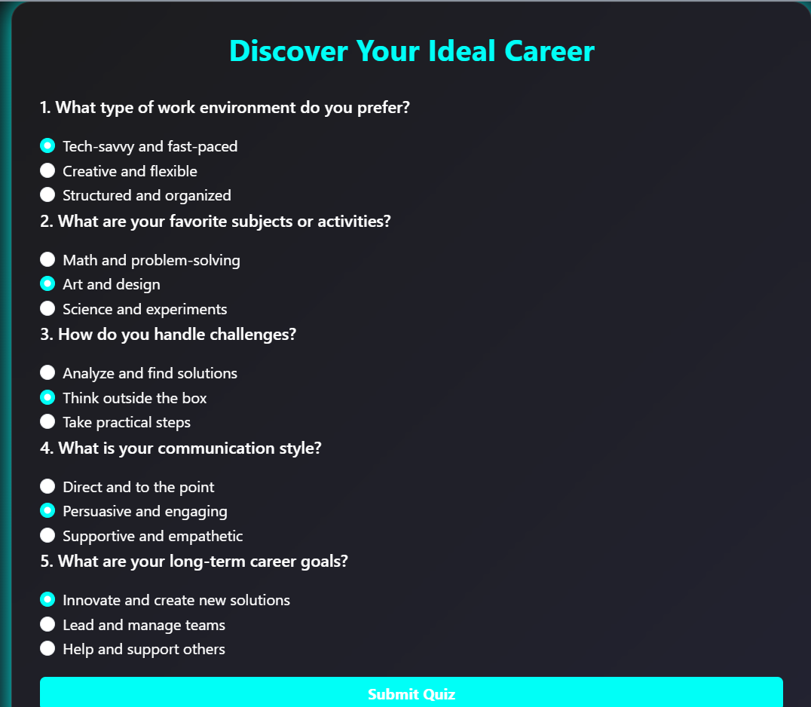

**15. Project Selection**

**javascript**

**// Route for Project Selection**

**app.get('/project-selection', isAuthenticated, (req, res) => {**

**const projects = [**

**{ title: 'AI Chatbot', description: 'Develop a chatbot using NLP techniques' },**

**{ title: 'IoT Smart Home', description: 'Create a smart home system using IoT' },**

**{ title: 'Autonomous Vehicle', description: 'Design and develop an autonomous driving system' },**

**];**

**res.render('project-selection', { projects });**

**});**

**Output View (project-selection.ejs):**

**html**

**<!DOCTYPE html>**

**<html lang="en">**

**<head>**

**<title>Project Selection</title>**

**</head>**

**<body>**

**<h1>Select Your Project</h1>**

**<ul>**

**<% projects.forEach(project => { %>**

**<li>**

**<h2><%= project.title %></h2>**

**<p><%= project.description %></p>**

**</li>**

**<% }) %>**

**</ul>**

**<a href="/dashboard">Back to Dashboard</a>**

**</body>**

**</html>**

**Purpose: Guides users to select projects relevant to their skills and career aspirations.**

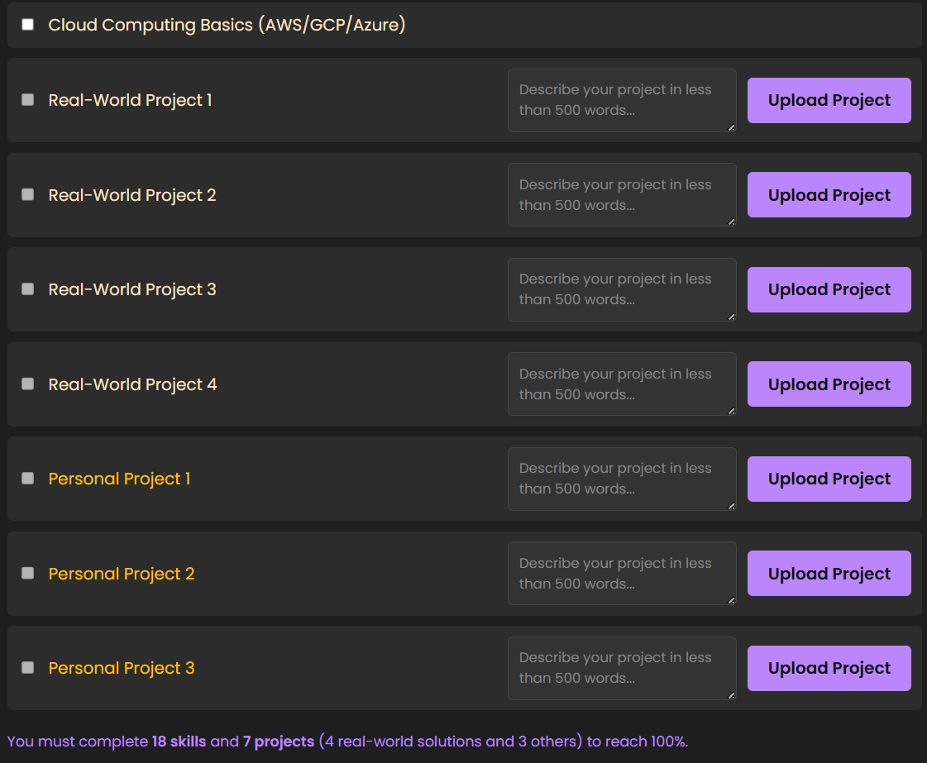

**CHAPTER 7**

**1. Examples of Test Cases**

**Test Case 1: Career Preference Matching**

* **Scenario: User seeks guidance for a career that aligns with their interests.**
* **Expected Result: Application recommends careers based on user-entered preferences and displays suitable options with rationale.**
* **Outcome:**
  + **Successfully matches career options to user preferences.**
  + **Logs: "Career preferences accurately matched."**

**Test Case 2: Inaccurate Data Inputs**

* **Scenario: User provides incomplete or inaccurate data for assessment.**
* **Expected Result: Application prompts user to complete missing fields or provides suggestions based on available data.**
* **Outcome:**
  + **Suggests corrective inputs or guides users to refine their answers.**
  + **Logs: "Data validation handled gracefully."**

**Test Case 3: Labor Market Trends**

* **Scenario: Application integrates real-time job market trends to provide recommendations.**
* **Expected Result: Updated recommendations based on current industry demands and salary expectations.**
* **Outcome:**
  + **Successfully retrieves and incorporates labor market data into guidance.**
  + **Logs: "Recommendations updated with real-time trends."**

**Test Case 4: Diverse User Backgrounds**

* **Scenario: User comes from a non-conventional educational background or career trajectory.**
* **Expected Result: Application offers personalized recommendations taking unconventional profiles into account.**
* **Outcome:**
  + **Provides tailored career options with an explanation of transferable skills.**
  + **Logs: "Successfully analyzed diverse user profiles."**

**Test Case 5: Scalability and Multi-Language Support**

* **Scenario: Application handles high traffic volumes and provides career guidance in multiple languages.**
* **Expected Result: Ensures seamless functionality for a large number of users and delivers accurate translation/localization.**
* **Outcome:**
  + **Handles peak usage without delays and provides precise recommendations in user-preferred languages.**
  + **Logs: "Scalability and multilingual support functioning optimally."**

**Advanced Solutions**

**7.1- Enhanced AI Algorithms**

* **Context-Aware Recommendations: Incorporate AI models capable of analyzing user context deeply (e.g., geographic location, local job market trends, skills demand) to provide highly personalized suggestions.**
* **Predictive Career Pathing: Utilize predictive analytics to foresee potential career trajectories based on user skills, aspirations, and current market trends.**

**7.2- Data Integration and Partnerships**

* **Real-Time Job Data: Establish partnerships with job portals, government employment agencies, and professional organizations to pull real-time job data directly into the application.**
* **Verified Data Sources: Integrate APIs from verified institutions to ensure data accuracy, reliability, and credibility.**

**7.3- Gamified User Engagement**

* **Career Simulations: Offer interactive simulations where users can virtually "experience" careers to help them visualize job roles, environments, and responsibilities.**
* **Achievement Badges: Implement gamification by rewarding users with achievement badges for completing assessments or exploring new career options.**

**7.4- Ethical AI Practices**

* **Bias Mitigation: Regularly audit the system's algorithms to eliminate biases that might favor specific demographics or career options.**
* **Transparency: Ensure users understand how recommendations are generated through accessible explanations and ethical disclosures.**

**7.5- Continuous Learning**

* **Adaptive Learning Models: Employ machine learning algorithms that evolve based on user interactions, feedback, and market changes, ensuring the recommendations remain current and effective.**
* **Expert Consultations: Embed options for users to connect with human career advisors to supplement AI-guided recommendations.**

**7.6- Accessibility**

* **Inclusive Design: Optimize the application for accessibility, ensuring functionality for users with disabilities (e.g., screen reader support, easy navigation tools).**
* **Mobile and Offline Support: Develop mobile and offline versions to extend access in areas with limited internet connectivity.**

**CHAPTER 8:**

**8. Limitations & Future Work**

## **8.1 - Current Limitations**

## **Static Career Matching Framework:**

## The system relies on predefined career paths and skill mappings. This approach may fail to adapt quickly to emerging roles, such as those in AI, blockchain, climate technology, and the gig economy.

## **Manual Data Updates:**

## Industry trends, salary benchmarks, and educational requirements are updated manually, resulting in delays and outdated insights compared to the evolving job market.

## **Limited Career Diversity:**

## The system focuses on traditional career fields (e.g., Engineering, Medicine, Business) but lacks robust support for niche and unconventional paths (e.g., Ethical Hacking, Social Media Influencing, UX/UI Design).

## **User Input Dependency:**

## Recommendations are highly dependent on the accuracy and completeness of self-reported data (e.g., skills, interests). This can lead to mismatched or incomplete career suggestions.

## **Scalability Challenges:**

## The system struggles with maintaining performance and personalization for a growing number of users, especially when handling complex analytics for diverse profiles.

## **Language and Regional Limitations:**

## Limited support for regional languages and globally diverse career opportunities may exclude non-English users or international candidates.

## **8.2 - Ideas for Improvement**

## **AI-Driven Career Mapping:**

## Develop adaptive machine learning models to predict career paths based on user profiles (interests, skills, academic performance) and real-time labor market trends.

## Enable dynamic updates for emerging industries, ensuring recommendations remain relevant.

## **Real-Time Data Integration:**

## Collaborate with job portals (e.g., LinkedIn, Glassdoor) and educational platforms to embed APIs that fetch live data on job openings, salary expectations, and required qualifications.

## **Support for Niche Careers:**

## Expand the database to include unique career paths, such as Ethical Hacking, Data Science, Creative Writing, and Renewable Energy. Provide detailed roadmaps for entry into these fields.

## **Enhanced Accuracy:**

## Implement feedback loops to refine suggestions by learning from user outcomes and satisfaction ratings. Include questionnaires to clarify ambiguous inputs and reduce false positives/negatives.

## **Scalability Optimizations:**

## Build cloud-based infrastructure to ensure smooth handling of large user bases.

## Utilize caching and load balancing for faster recommendations and user-friendly experience.

## **Multilingual & International Support:**

## Introduce regional language options for assessments and recommendations.

## Incorporate diverse career pathways tailored to specific countries and cultural contexts.

## **Customizable Learning Roadmaps:**

## Offer tailored learning pathways that include certifications, online courses, internships, and mentorship programs. Allow users to set goals and track progress towards their desired careers.

## **Gamification Features:**

## Add interactive quizzes, career simulation tools, and achievement rewards to enhance user engagement and improve decision-making confidence.

## **Ethical Guidance Practices:**

## Implement AI fairness audits to ensure unbiased recommendations across demographics. Provide disclaimers that encourage users to supplement results with personal exploration or expert advice.

## CHAPTER 9: CONCLUSION

##### 9.1 - Summary of What Was Achieved

The Career Guidance System successfully assists students in making informed career

decisions by analyzing their skills, interests, and academic performance. The system

provides personalized career recommendations, helping users explore suitable career

paths and required skill sets.

#### Key achievements include:

* Personalized career recommendations based on user inputs (skills, interests,

academic background).

* Integration of industry trends to suggest relevant and emerging career opportunities.
* Skill gap analysis to guide users on necessary certifications or courses for their desired careers.
* A user-friendly interface that simplifies career exploration for students with varying levels of technical knowledge.

### 9.2 - Final Thoughts on Usefulness and Impact

The Career Guidance System serves as a valuable tool for students, educators, and career counselors by simplifying the career decision-making process.

It reduces uncertainty by providing data-driven insights into job markets, required qualifications, and future growth opportunities.

While the system has limitations (such as reliance on manual data updates and limited

niche career coverage), it establishes a strong foundation for future improvements.

Enhancements like AI-driven predictions, real-time job market data integration, and

mentorship features could further refine its accuracy and usability.

Ultimately, this project has the potential to bridge the gap between education and

employment, empowering students to make confident career choices and adapt to

evolving industry demands. With continued development, it could become an

essential resource for career planning in the digital age.